Class Time:
Names:

The Chi-Square Distribution: Chi-Square Test for Independence Lab II

Student Learning Outcome:

The student will evaluate if there is a significant relationship between favorite type of snack and gender.
Collect the Data:
- Using your class as a sample, complete the following chart.

Favorite type of snack by Gender
 | sweets (candy & baked goods) | ice cream | chips & pretzels | fruits & vegetables | Total
male

female

Total

- Looking at the above chart, does it appear to you that there is dependence between gender and favorite type of snack food? Why or why not?

Hypothesis Test
Conduct a hypothesis test to determine if the factors are independent

- Ho: ____________

- Ha: ____________

- In words, define the random variable

- The distribution to use for the test is

- Calculate the test statistic using your data.

- Draw a graph and label it appropriately. Shade the actual level of significance. Then calculate the p-value.
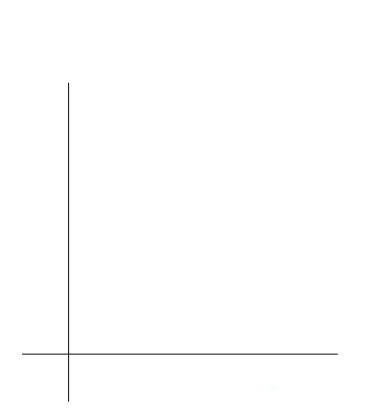
- State your decision

- State your conclusion in a complete sentence.

Discussion Questions

- Is the conclusion of your study the same as or different from your answer to “Collect the Data” question 2?

- Why do you think that occurred?

